Insert Subject | Dragon Sensory Experience
Insert NCL/KSL
Date:

By the end of these activities: | Most Pupils Will…  Create Dragon themed sensory objects
Some Pupils Will…
Incorporate the Dragon themed objects they have created to create a Dragon Cave scene
Few Pupils Will…
Re-enact or identify scenes in a book using the sensory Dragon Objects created

Activity | Step by Step | Resources | Cross- curricular Links | Sensory Input
 |  |  |  |  | Achieved | Revisit | Redo
Activity 1- Dragon Egg  To develop my tactile and visual senses to create a dragon egg.  I can design and create a dragon egg of my own design  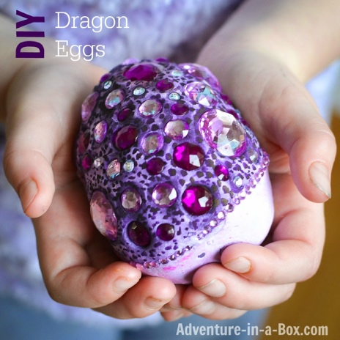 | - Roll aluminum foil into a ball/egg shape  - Cover the ball in air drying clay  - Use shiny/colourful objects such as gems, sequins, beads, shells etc. and push them into the clay  - Allow the clay to dry  - Optional- add paint layer using sponges to give the egg texture | Foil  Airdry clay  Shiny objects  Paint | - English  - Maths  - Science  - Art  - PSHE | - Visual  - Proprioception  - Tactile
Activity 2- Breathing Fire  To develop my olfactory sense by using my oral muscles to blow dragon fire  I can create a dragon fire blowing tube  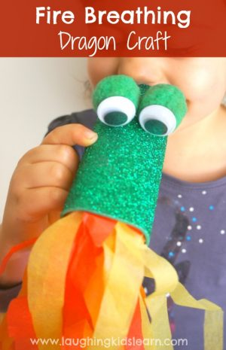 | - Shred paper or tissue paper into long strips  - Using a empty loo roll tube, glue the long strips at one end  - You can decorate the rest of the tube into a dragon if you wish  - Get pupil to blow in the end of the loo roll opposite to the side to the shredded paper to make it move | Loo roll  Shredded paper  Stuff to decorate if chosen | - Science  - Art  - PSHE | - Visual  - Proprioception  - Vestibular  - Taste  - Smell
Activity 3- Feed the dragon  To develop my proprioceptive and visual senses by feeding the dragon  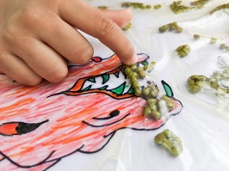  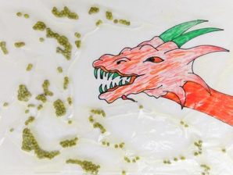  I can manipulate objects to go into the dragons mouth | - Sketch the dragon on the paper(you may chose to laminate this),you can draw a bird or a monster, anything of your choice.  - Place the paper inside the ziplock cover, add in some green lentils/breads/gems and a small cup of baby oil  - Seal the cover and tape it down on the floor or a table. Seal on all sides.  - Ask pupil to move the the objects into the dragon to feed it | Zip lock bag  Baby oil  Dragon picture  Objects to feed the dragon | - Maths  - Science  - Art | - Visual  - Proprioception  - Vestibular  - Tactile
Activity 4- Dragon Slime  To develop my tactile and olfactory senses by creating dragon slime  I can create dragon slime  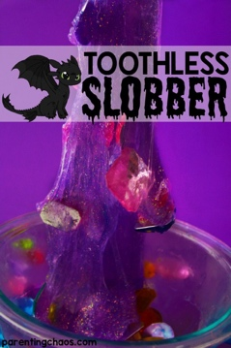 | - Pour all of your Elmer’s coloured Glitter Glue into the bowl (purple is great for this). Elmer’s glue is the easiest to work with although any brand will work.  - Add in your gems.  - Pour in your liquid starch. If you are using Elmer’s Glue you really cannot get this wrong. If you are using an off brand only add in one tablespoon at a time until you reach the right consistency.  - Stir. Or just dig your hands in and get slimy  - Enjoy! |  | - Maths  - Science  - Art | - Visual  - Proprioception  - Tactile  - Smell
Activity 5- Dragons Cave  To develop my proprioception (calming), vestibular visual, and auditory skills by discovering dragons in the cave  I can identify where dragons are located in the cave using my sense detective skills | - Create a dark space- this maybe the whole classroom, corridor or a dark den- you can make it as simple or as Dragon Cave like as you like! This is a great opportunity to use the objects created previously  - You may chose to put on some background music to set the scene or use sound bottles  - Place pictures/teddies of dragons around the space  - Using a torch ask the pupils to discover where all the dragons are hidden  - Once they are all found you may ask pupils to relax and read a dragon themed book (Zog is great for this!) using the torch to read with | Dark space  Dragons,  Torch,  Dragon book,  Music or sound bottles | - English  - Maths  - PSHE | - Auditory  - Visual  - Proprioception  - Vestibular  - Tactile

