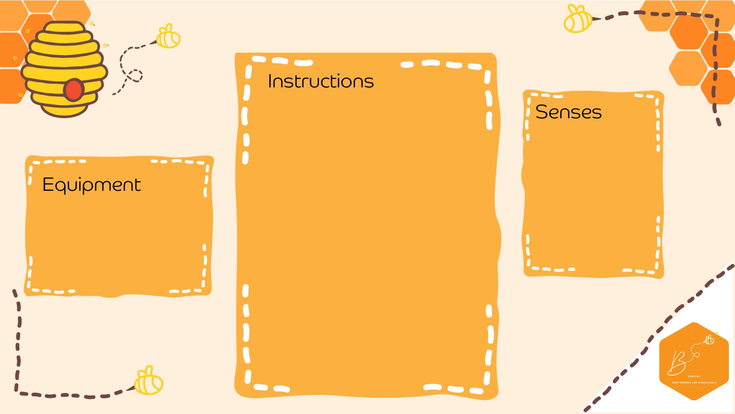

•

In your plastic b

ottle

,

fill

¼

with

clear PVA

gl

ue

•

Add leaf and

au

tu

mn

gl

itter confetti

•

Add food colouring to

water

•

F

ill the rest of the

bottle

with

the

c

olou

red wa

ter

•

Attach the bottle lid

and

ta

pe

if requi

red

Visual

•

Pla

stic bottle

•

PVA

glue

•

Autumn conf

etti

•

Water

•

Food colouring

**Autumn Sensory Bo**

**ttle**