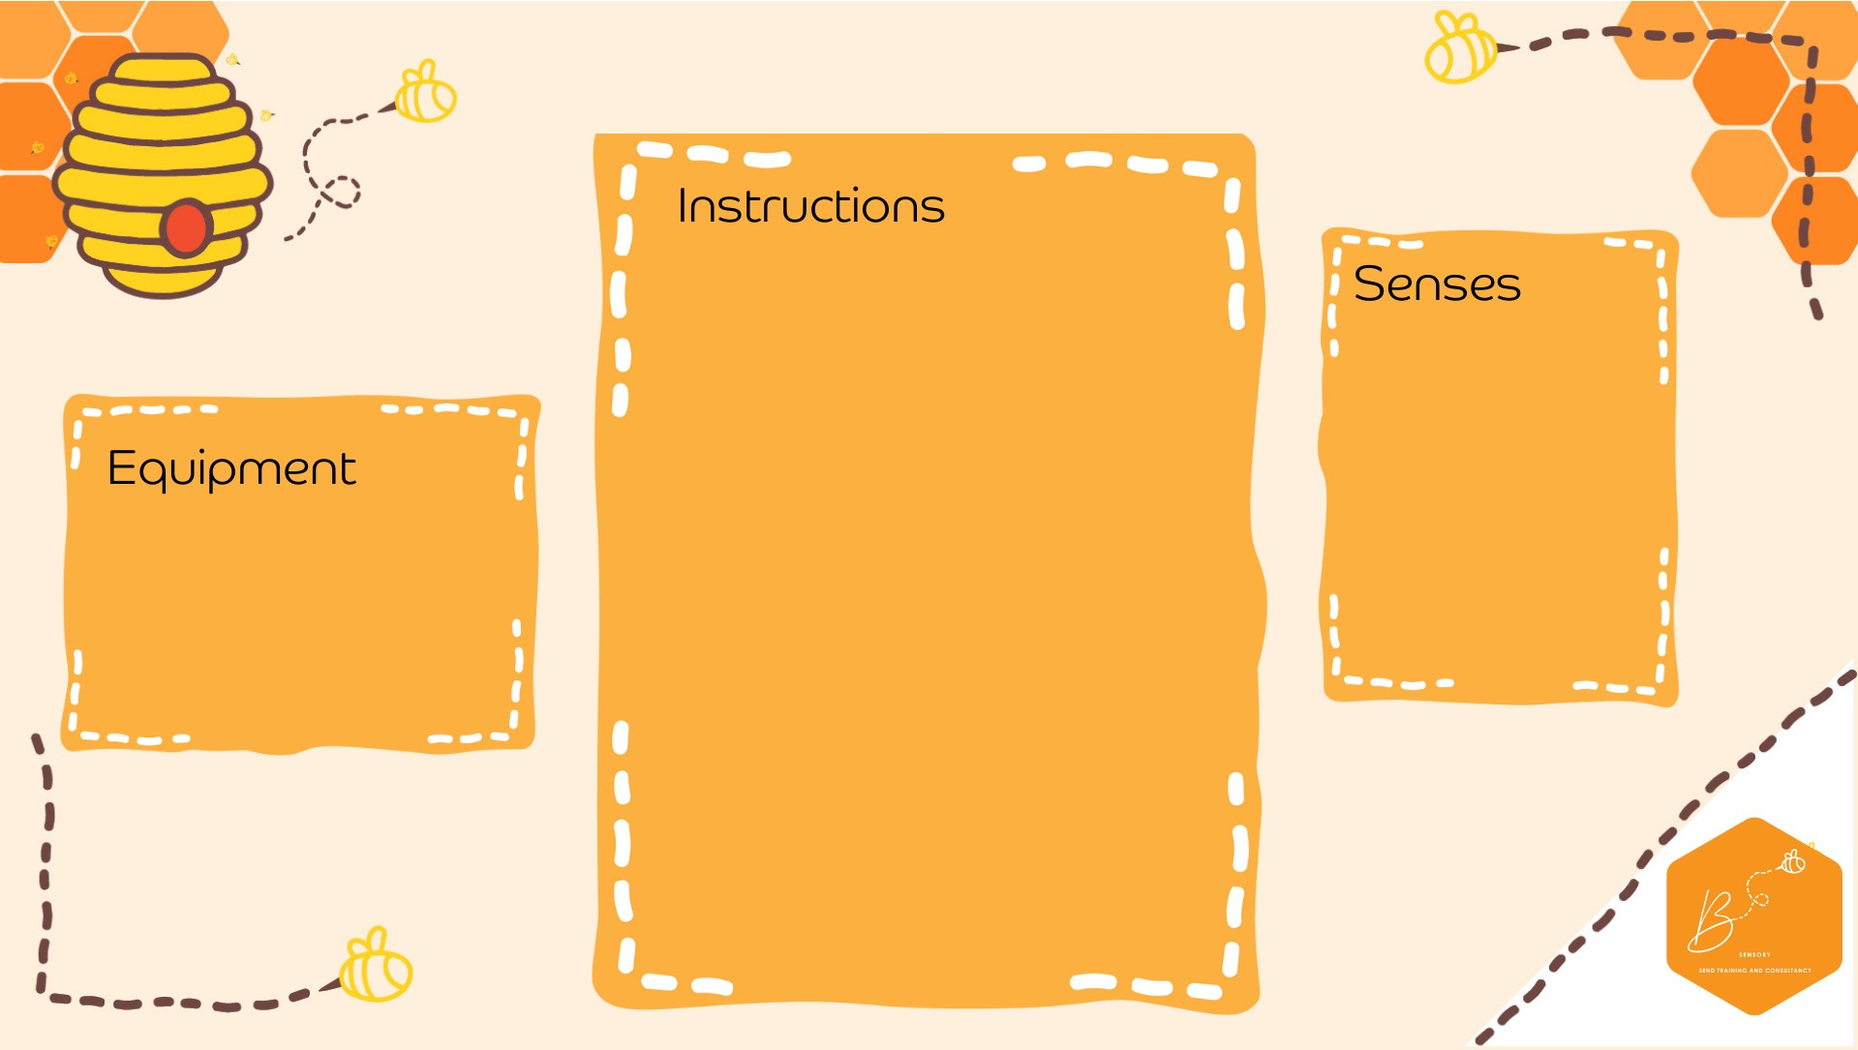

•

*** Sharp knife

–

adu

lt

only.

Please t

ake c

are

***

•

Cut the top off the pumpkin

•

Sc

oop

the seeds out

•

Place

pumpkin on a tray

•

A

dd a few

hea

ped teaspoo

ns

of b

aking soda into the

pumpkin

•

Add a few drops of

dish soap

and food colouring

inside

•

Us

i

ng droppers, drop some

vinegar

into the pumpkin

•

Wa

tch it bubble

•

For cauldron, paint the pumpkin

black and add a handle

Auditory

Visual

•

Pump

kin

•

Baking So

da

•

Vinegar

•

Dish Soap

•

Gre

e

n food colouring

•

Tray

**Bubbling**

**Pump**

**kin**

**/Cau**

**ldron**