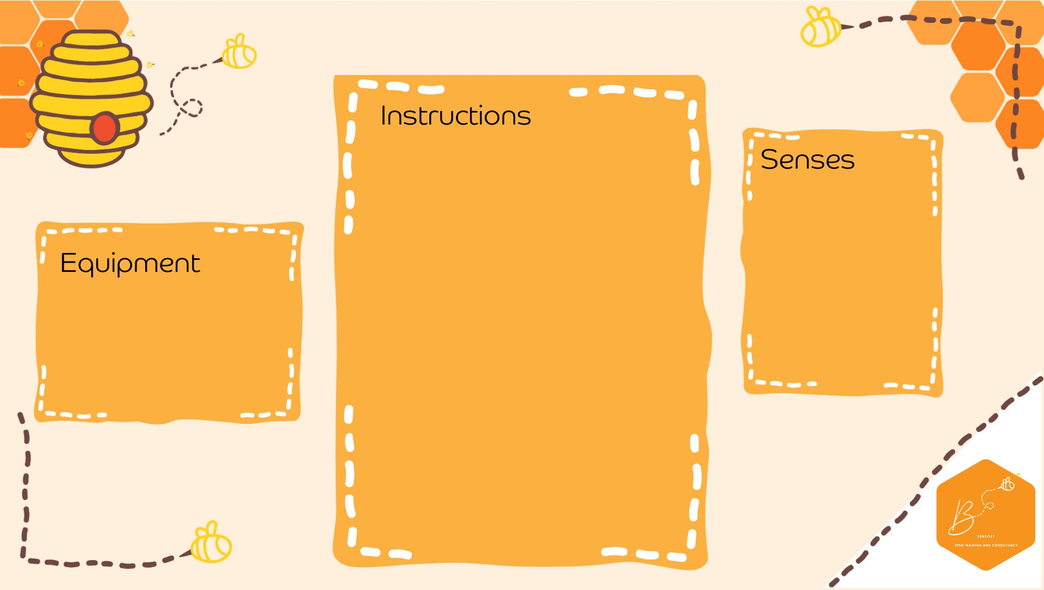

•

Pull and be

nd the straws

•

Fold over the bend to

make a

U shape

•

C

ut

the stem of the straws off

•

Attach a paper

clip onto both

ends of

the straw

•

A

dd

more

paper clips on to

make a small chain (3

-

clips

)

5

•

Place into the plastic bottle

•

Fill the bottle to al

most full

leave

(

approx.

cm from th

3

e

top)

•

Place the lid on the bottle

•

Squeeze and watch the

ghosts move

Visual

Propriocep.on

•

White straws

•

White paper clips

•

Empty plastic

drink b

ottle

•

Water

•

S

c

issors

**Gh**

**ost Sensory Bottle**