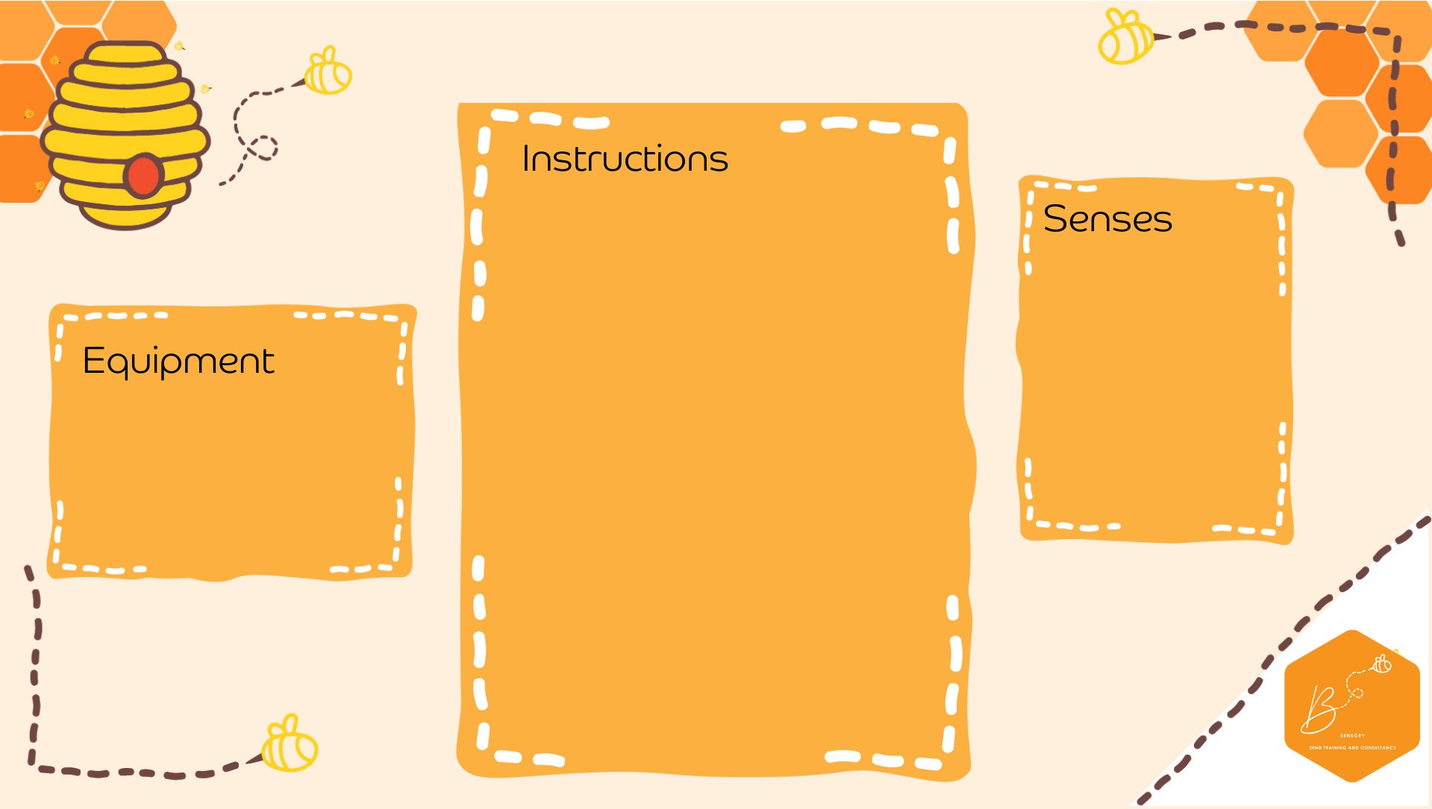

•

Slice

the pumpkin in half

•

Sc

oop

out the guts and

seeds and store in a di

sh

•

I

n a

separate

bowl add

2

cups of corn

flour

•

Mix water

with some

orange

/yellow food

colo

uring in a jug

•

Add

water bit

by b

it until

the mixture

become

s

gloopy but not runny

•

Add in the guts and seeds

•

Experiment

wit

h the

gloop

-

if you slap it

, it

goes solid

Visual

Touch

Propriocep0on

•

Pumpkin

•

Corn

flour

•

Water

•

Food colouring

•

Cup

•

Spare

dish

**Pumpkin Goop (O**

**obleck)**