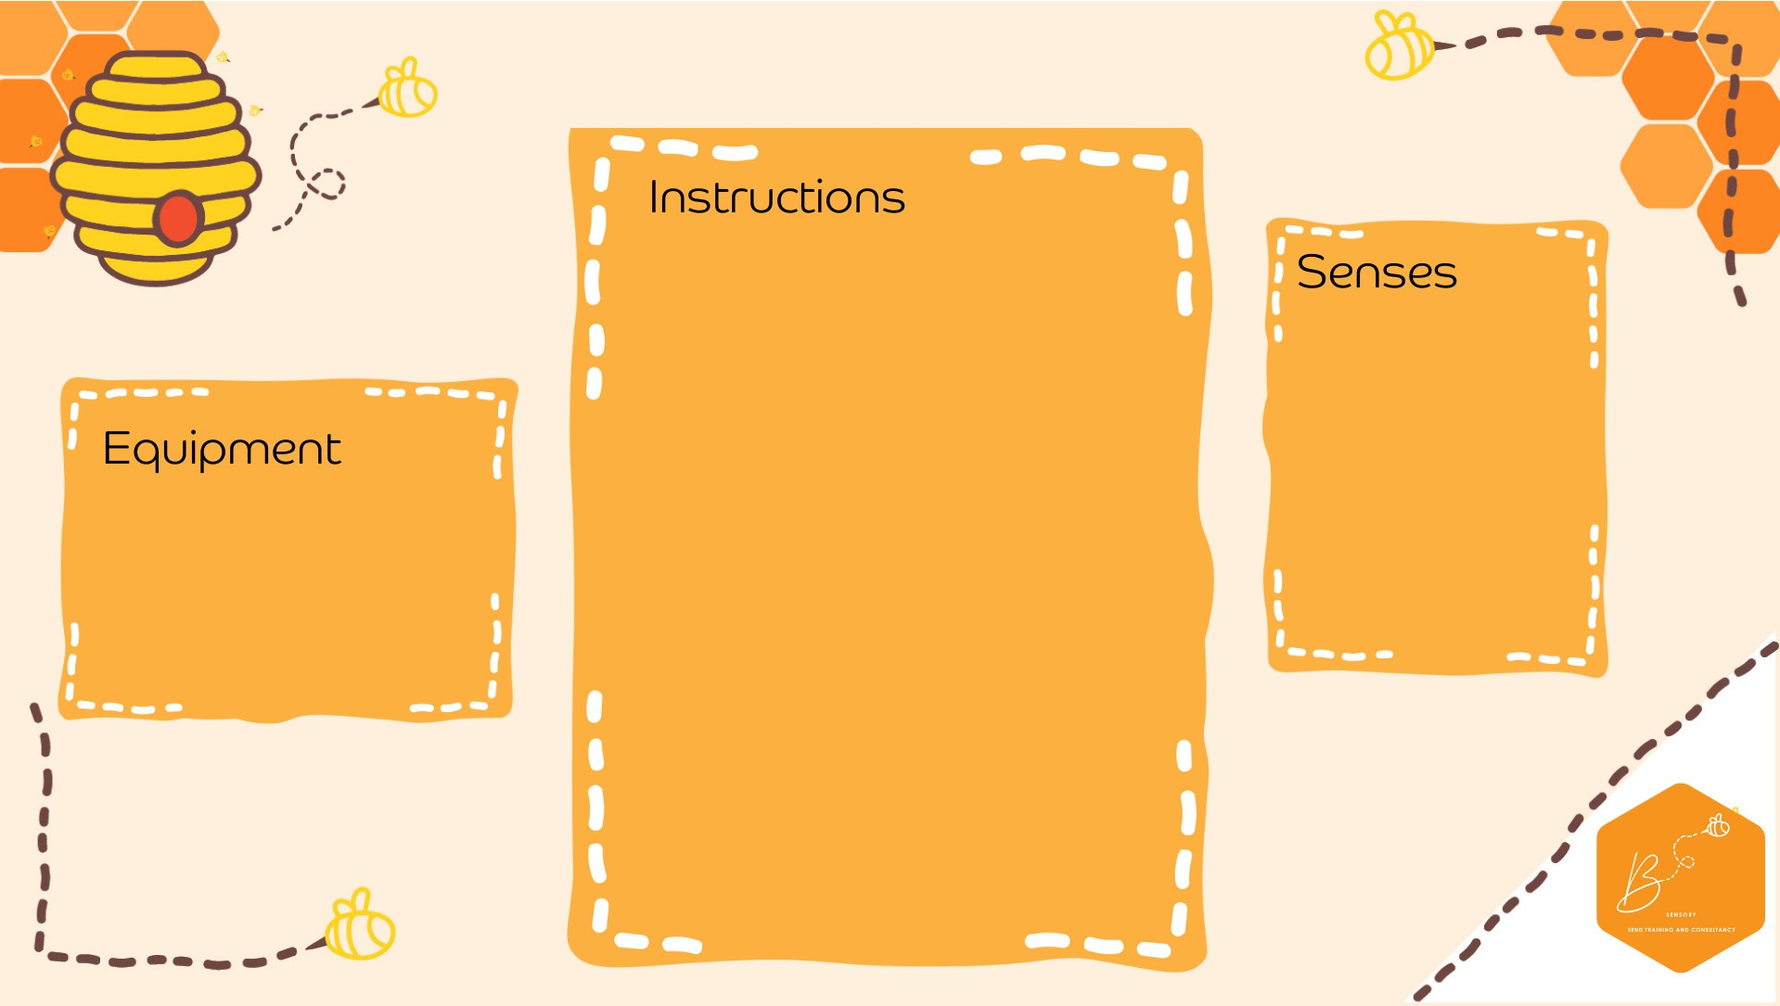

•

I

nside of the clear

plastic box, tap

e the

fai

ry lights

/LED

lights

so that

the

lights are

facing up towards t

he

lid

•

Turn the lights on

•

Place the lid on

top

(

tape to secure if

needed)

•

Place sand on

top of the

lid

Visual

Touch

•

Cl

ear plastic box

•

Battery Fairy

Lights

•

Tape

•

Sand

**Sand Li**

**ght**

**Box**