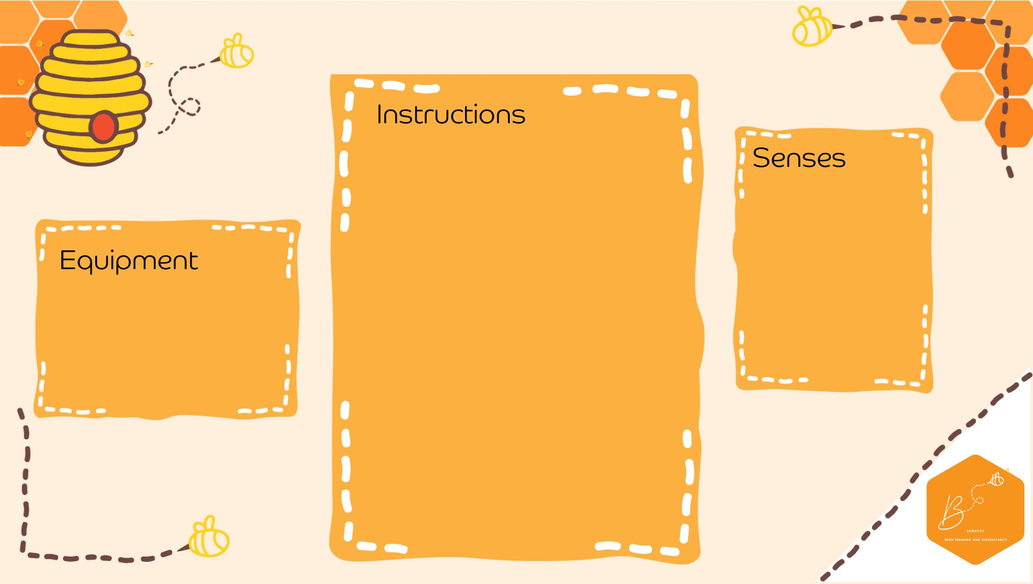

•

Beat 140 grams of soft butter with 60 grams

of caster sugar until you have a paste

•

Sprinkle in 190 grams of plain flour, 1 tsp of

cinnamon and 1tsp of mixed spice and stir

until you have crumbs

•

Then work with your hands until you have a

soft paste/dough ball

•

Roll out on a floured surface (about 1 cm

thick) and cut up with cutters.

•

Place on baking sheet and sprinkle with a

little more sugar.

•

Leave in fridge to cool while your oven

preheats to 190 degrees.

•

Bake for 15 mins or until the right colour.

•

Cool before

eating

•

Olfactory

Touch

Propriocep2on

•

g butter

140

•

)

room temperature

(

•

g caster sugar

60

•

g plain flour

190

•

1

tsp cinnamon

•

1

tsp mixed spice

**Spice**

**d B**

**iscuits**