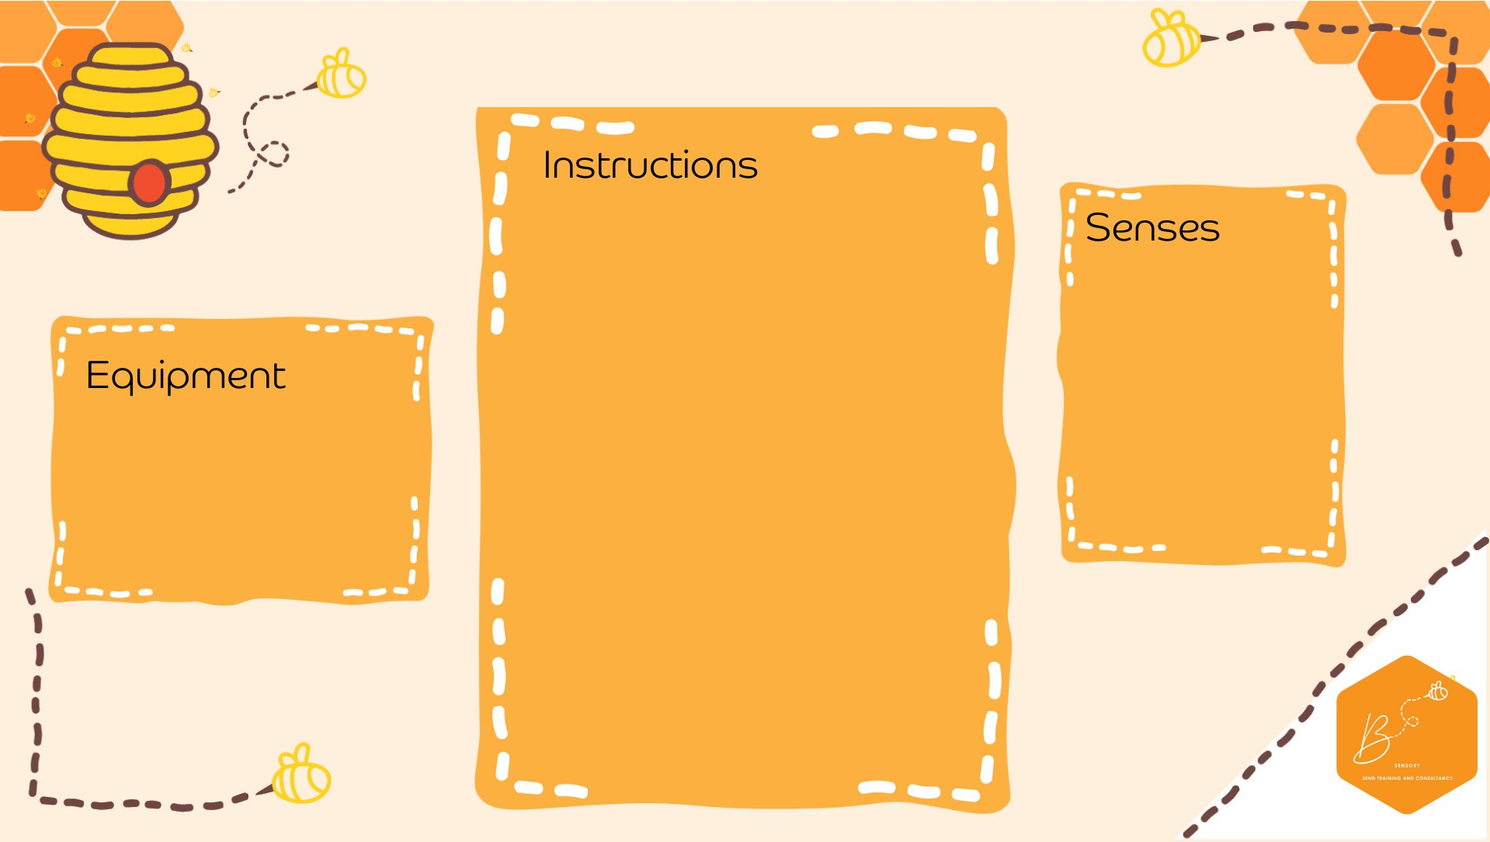

•

Draw a spider

onto

a

piece

of paper

•

Plac

e 8 pom poms

into the cent

re

•

Using

a straw, blow

the pom poms

onto the spiders

feet so that each

foot has

o

ne pom

pom on

Visual

Olfactory

Propriocep2on

•

Paper

•

Sha

r

pie

•

St

raw

•

Pom P

oms

**Spide**

**r Fee**

**t B**

**low**