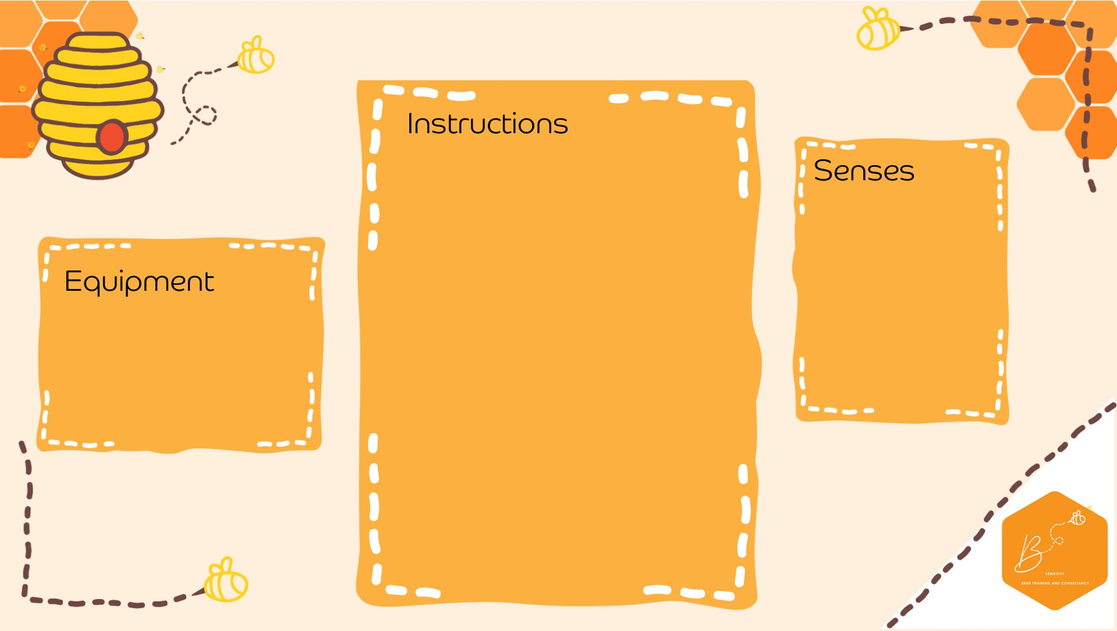

•

Using a small recorder or

phone

recording e

xperimen

t

with the

below, and record spo

o

ky sounds

-

B

lowing

i

nto an e

mpty

bottle to

sou

nd like

an owl

-

Running

a wet

finger

around the rim

of a

glass to

create ghost sounds

-

Flapping a bucket hat to sound like

bat wings

-

Crashing

cutlery

onto a metal tray for

glass breaking

-

Empty cups together to sound a like

haunted

horse galloping

-

A

boiling

kettle

for a cauldron

-

Pulling

alon

g

some str

ing underneath

a p

lastic cup

-

Blowing

into a turkey baster

-

Using a blunt saw and bending it or

use a vi

olin bow

-

Auditory

Propriocep.on

•

Sound

rec

order

•

Materials to

make spooky

sounds

**Spooky Sound Collecting**